Product Design

## Use Cases

|  |  |  |  |
| --- | --- | --- | --- |
| Use Case ID: | 1 | | |
| Use Case Name: | Book faculty on website manually | | |
| Created By: | boyshawn | Last Updated By: | boyshawn |
| Date Created: | 23/10/2016 1:07 PM | Date Last Updated: | 31/10/2016 12:01 AM |

|  |  |
| --- | --- |
| Actor: | User |
| Description: | This is the most usual scenario of a user booking a sport facility on the Sports Hub website. |
| Preconditions: | 1. User has internet access 2. User has a valid NRIC |
| Postconditions: | Describe the state of the system at the conclusion of the use case execution. Number each postcondition. Examples:   1. Document contains only valid SGML tags. 2. Price of item in database has been updated with new value. |
| Frequency of Use: | Once per week |
| Normal Course of Events: | 1. User enters the Sports Hub booking page. 2. Sports Hub booking page loads. 3. User chooses the type of facility he will like to book. 4. User chooses the facility from the dropdown list provided. 5. User clicks on the date he will like to check for available facilities. 6. Sports Hub booking page shows him the available slot available for each timing. 7. User choose the timing he wishes to book. 8. Sports Hub booking page prompts user to go to **continue booking** or **go to basket**. 9. User chooses to **go to basket**. 10. User fills in his particulars and clicks on **Confirm booking**. 11. Sports Hub booking page shows User’s booking confirmation and sends a booking email to his email account. |
| Alternative Courses: | 7.a.1. User is not able to locate a desired time slot on that day.  7.a.2. User repeats step 5 to 7 until he finds the available time slot he wants.  8.a.1. User clicks **continue booking**.  8.a.2. User repeats step 3 to 8 until he chooses **go to basket**. |
| Exceptions: | NIL |
| Assumptions: | NIL |

|  |  |  |  |
| --- | --- | --- | --- |
| Use Case ID: | 2 | | |
| Use Case Name: | Book faculty using Booking Automater | | |
| Created By: | boyshawn | Last Updated By: | boyshawn |
| Date Created: | 31/10/2016 12:01 AM | Date Last Updated: | 31/10/2016 12:01 AM |

|  |  |
| --- | --- |
| Actor: | User, Sports Hub Booking System |
| Description: | User use the Booking Automater to book a facility.  Provide a brief description of the reason for and outcome of this use case, or a high-level description of the sequence of actions and the outcome of executing the use case. |
| Preconditions: | 1. User has internet access 2. User has a valid NRIC 3. User is a Singaporean |
| Postconditions: | A booking facility is booked. |
| Frequency of Use: | Once per week |
| Normal Course of Events: | 1. User executes the program with his particulars, desired booking days, and type of facility. 2. Booking Automater provides the confirmed booking times. 3. Sports booking system sends a confirmation email to the User. |
| Alternative Courses: | 2.a.1. There is a no available slot for that day.  2.a.2. User repeats the process with other day. |
| Exceptions: | 1. User does not have an internet connection. Error message will be shown. 2. User does not have a valid NRIC. Error message will be shown. 3. User keys in an invalid email address. Sports booking system will not send the confirmation email to the User. |
| Assumptions: | Assumption is that the Sports Hub booking is available for booking. |

Further improvement:

* Scheduled booking on a weekly/ daily basis, so that user can just key in once and the application book for him on the pre-stated timing.
* User can choose multiple time ranges for booking.

## Sequence diagram

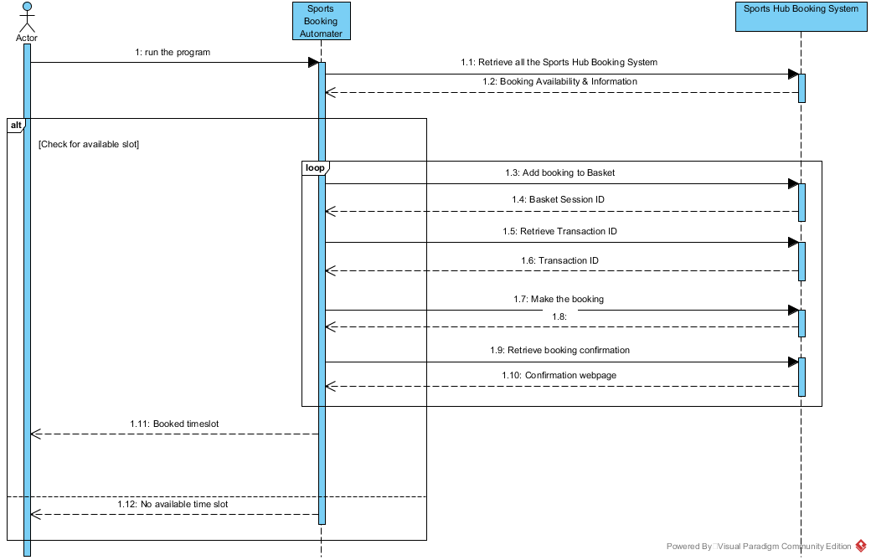

**Figure 1: Sequence Diagram 1: Interaction between Actor, Sports Bookng Automater & Sports Hub Booking System (High Level)**

## Class model diagram

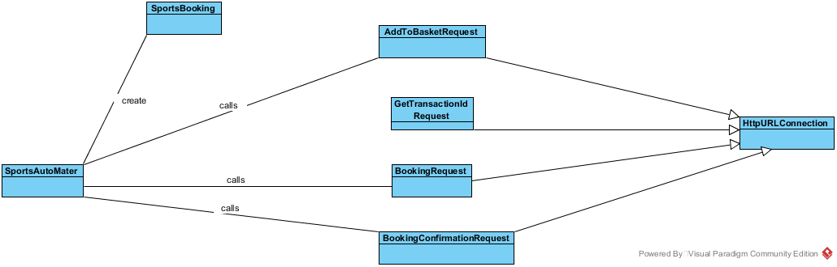

**Figure 2:Class Diagram 1: Sports Booking Automater**